

STUDENT CASE STUDY EXECUTION REPORT

Department | FED
Subject | DSA-2
Academic Year | I-III Semester (2025-26)
Faculty Name | Balaiah G
Student Name | I.Vikram
Roll Number | 2520090118
Branch | CSIT
Course Outcome | Evaluate and Implement advanced sorting algorithms-Quick sort,Merge sort,Heap Sort,Counting Sort and Radix Sort
Case Study Topic: Booking Status Partitioning

Work Done Summary:

• Created an array of booking statuses (S, P, F).
• Applied the Dutch National Flag algorithm.
• Used three pointers (low, mid, high) to partition the array.
• Moved all SUCCESS entries to the beginning.
• Kept all PENDING entries in the middle.
• Moved all FAILED entries to the end.
• Completed partitioning in a single traversal.
• Used constant extra memory.

Implementation Details:

• Create an array containing the booking statuses (SUCCESS, PENDING, and FAILED).

• Initialize three pointers:

low → marks the beginning of the SUCCESS region.

mid → scans the array.

high → marks the end of the FAILED region.

• Start scanning the array from the beginning using the mid pointer.

• If the current status is SUCCESS, place it in the SUCCESS region by swapping it to the front, then move both low and mid forward.

• If the current status is PENDING, leave it in the middle region and move mid forward.

• If the current status is FAILED, move it to the end region by swapping it with the element at high, then move high backward.

• Continue this process until the mid pointer crosses the high pointer.

• After completion, all SUCCESS records appear first, followed by all PENDING records, and all FAILED records at the end.

• Display the partitioned array and verify that the statuses are grouped correctly.

• Analyze the performance of the algorithm, which completes the partitioning in one pass using constant extra memory. Result: Screenshots / Output

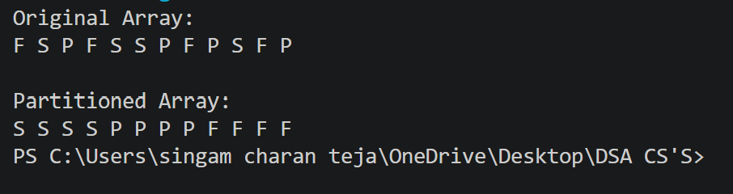

• The Dutch National Flag algorithm successfully partitioned the booking statuses into three groups.

• All SUCCESS records were placed at the beginning of the array.

• All PENDING records were placed in the middle of the array.

• All FAILED records were placed at the end of the array.

• The final partition obtained was [SSSS | PPPP | FFFF].

• The partitioning was completed in a single traversal of the array.

• No additional memory was required apart from the three pointers.

• The algorithm achieved O(n) time complexity and O(1) space complexity.

• The approach efficiently organized booking requests for faster downstream processing.

